**Mr. Visca’s: Calculus (Chpt 2.4)**

**Chpt 2 – Day 10 Instantaneous Rate of Change**

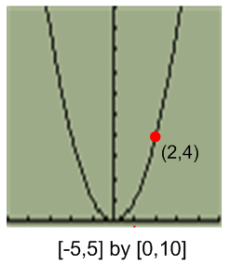**Instantaneous Rate of Change:**

Find the slope of the parabola y = x2 at point (2,4).

Ultimately, its the ________________________ at that point on the curve.

Now find the equation of the tangent line.

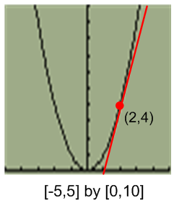slope-intercept: point-slope:

Now find the equation of the normal line.

Find the equation of the tangent line and normal line of the equation f(x) = 4 - x2, at the point x = 1.



*HW: section 2.4*

*#s 9-12, 26, 30, 31b, 32*